What are the costs involved?

The RPP framework documents and technical support are free for all members. The company will then incur two cost elements, namely staff time and cost of the audit.

Staff time
A named individual within the company will be responsible for the policy and its procedures. The TTF will assist this staff member by producing template letters and reports, in electronic format. Staff time will be dependent on number and complexity of suppliers and the level of subsequent risk management.

Auditing Cost
Independent validation of Signatory performance is needed to ensure the credibility of the programme. The TTF is in discussions with a number of established UK auditors. We are still waiting to receive quotes from the auditors but it is anticipated that each Signatory will have to pay between GBP 200 – 600 per year. If non-compliances result in the need for on-site visits the cost for the individual Signatory concerned will rise proportionately.

Should all TTF members be part of the RPP?

The Code of Conduct was developed in full consultation with the membership and has been well received by government and other industry stakeholders who view it as evidence that our sector is setting high standards of performance and business practice.
Members are already making considerable efforts in supplier assessment but to fully promote those efforts for the Membership as a whole we need to have positive evidence of what our members are achieving. If all members sign up to the RPP we would have that opportunity. The Strategy Group are considering the question of making the RPP compulsory. The Governing Board will consider this issue in October 2004.

How can I start?

The RPP guidance notes and documents will be available from October 2004. Companies can then follow these easy steps:

OCTOBER – DECEMBER 2004
1. | Company Commitments; read through and sign the RPP Company Commitments, with a named individual becoming responsible for the implementation of the policy.
2. | Communicate the Company Commitments both internally to staff and externally to customers and stakeholders.
JANUARY ONWARDS 2005
3. | Risk Assessment; begin the process of Risk Assessment by sending out the Questionnaire with a covering letter informing each supplier of your Company’s commitment to the RPP and assess their current performance.
4. | Analyse responses using the Choice Tables. All company suppliers are then classified as either high, medium or low risk.
5. | Risk management; outline activities and set targets for high and medium risk suppliers. Engage TTF and stakeholders for assistance.
DECEMBER 2005
6. | Management Report; compile summary of Risk Assessment. Outline new activities and targets for the forthcoming year. (Include copy of purchase ledger).
JANUARY 2006
7. | Annual Audit; independent auditor to assess Management Report of all companies and visit a sample of companies.

For more information contact Dr Penny Bienz at the Timber Trade Federation on:

Address: Clareville House, 26/27 Oxendon St.
London, SW1Y 4EL.
Telephone: 020 7839 1891
Email: ttf@ttf.co.uk
Website: www.ttf.co.uk

Responsible Purchasing Policy

Frequently Asked Questions

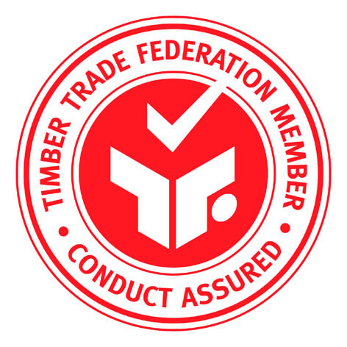
What is the RPP?
The RPP is a tool to assist members with the implementation of the TTF Code of Conduct.

What are the benefits of signing up to the RPP?

In recent years the timber purchasing environment has, and will continue, to change. Influences have come from both within the trade through Codes of Conduct and outside of the trade through consumer campaigns and government, looking to source timber from sustainable supplies. The benefits of a company using the RPP are that it provides:
- Risk Management; by providing a systematic approach to collecting information from their suppliers and developing a preferential suppliers list.
- Reassurance to customers that a company is actively selecting those suppliers that can provide the reassurance of legal and progressively sustainable supplies.
- Access to certain discriminating timber markets, such as central government and big construction companies.
- Clear evidence that the company is actively working to ensure all of its purchases are from legal and sustainable sources.
If a member company is associated with the supply of illegal timber, this association will be detrimental to the reputation and future business of both that company and other member companies of the Timber Trade Federation.
How will the RPP assist in accessing discriminating timber markets and satisfy the requirements of the new central government purchasing policy?

Customers increasingly require that timber and timber products are sourced from legal and well-managed forests. Companies are increasingly being asked to supply information on the origin of their timber supplies and in some cases this information has to be independently validated. In the absence of certification on some timber supplies, the RPP enables the company to provide supportive evidence on, at the very least, the legality of their timber supplies.

Is the RPP a simple system?

Yes! The RPP is an essentially simple concept. Many companies already have systems in place to monitor their suppliers. Where these systems primarily address financial and quality performance, perhaps on an informal basis, the RPP provides a comprehensive framework to monitor environmental considerations.
The key elements of the RPP include:

- Signing up to Company Commitments
- Performing a Risk Assessment of suppliers through a questionnaire approach
- Compiling a Management Report
- Undergoing an independent audit

All these elements have been successfully evaluated during the pilot testing and companies signing up to the RPP will receive full guidance on them.

How do we know it will work?
The development of the RPP has been overseen by a Project Group made up of members of the industry. Four companies have also Pilot Tested the policy; Wolseley UK, AW Champion Ltd, James Latham Plc and Howarth Timber Ltd. Pilot Testing involved risk assessing a sample of their supply base to see if the policy determined a good evaluation of suppliers. Pilot Testing then looked at establishing procedures to move suppliers from higher risk to lower risk categories.
During the development of the RPP the draft documents outlining the procedures were sent out to all TTF member companies, ENGOs, consultants and government officials. Discussion has also taken place during TTF Commodity Division and Governing Board meetings. Where practicable, all comments have been incorporated into the final documents.

How does the RPP incorporate the other environmental initiatives a company is working on?

Purchases made via recognised certification schemes or where other evidence of legality or sustainability is available, will automatically classify the supplier as lower risk. This will immediately reduce the level of further investigation required.

The RPP system concentrates company effort on those purchases where information is sparse and therefore risk may be high.

Will it recognise the diversity of the types of timber products and countries of origin for supplies into the UK?

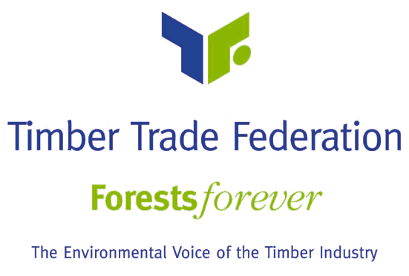
The RPP is being written by the industry, for the industry. The RPP looks for continuous improvement in a company’s supply base and recognises that different countries of origin will progress at different rates. The RPP is a mechanism to assist traders in gaining recognition in their existing supply base.

Who will set the targets and timescales for the RPP?

In the first year the Risk Assessment will produce a snapshot of the companies supply base and classify the suppliers as high, medium or low risk. RPP Signatories are committed to continuous improvement in their supplies and are expected to set their own targets to improve their supply base within a realistic timescale.

Different types of Target will be considered. An Action Target refers to a target where there is evidence that a specific action has been taken and a Timber Target refers to a target of increasing the volume of legal and sustainable timber within the supply chain.

How do you help your suppliers move from high to low risk?

Recommendations and guidance will be offered on how to work with the high and medium risk suppliers so they become low risk suppliers. High risk supplies may need to concentrate on Action Targets which may involve engaging with country based stakeholders and obtaining reassurances of legality from independent auditors.

The TTF will provide policy holders with County Profiles and a list of service providers within high risk supply areas. Furthermore information will be provided of UK and EU Initiatives, including legislation or funding.

Tell me about the Audit process. How will it work?

The audit will consist of a stratified sampling approach following production of the Management Report. The independent validation process will be undertaken as a single block of work in January or February each year.

For a proportion of Signatories the Management Report will be followed up by a telephone interview. The selection of Signatories for telephone interview will be determined by the contents of the Management Report and some will also be selected randomly. A further sub-set of Signatories will be selected for site visits when the auditors will physically check the functioning of the Risk Assessment system.

If problems or non-compliances are identified, the independent auditor will issue Corrective Action Requests (CARs) just like other certification programmes. Minor CARs will be resolved between the Auditor and the company. A Major CAR may involve reference to procedures under the TTF Code of Conduct. Under normal circumstances the TTF will not have access to sensitive supplier information or be part of the independent validation process.

