UK Timber Trade Federation’s Responsible Purchasing Policy

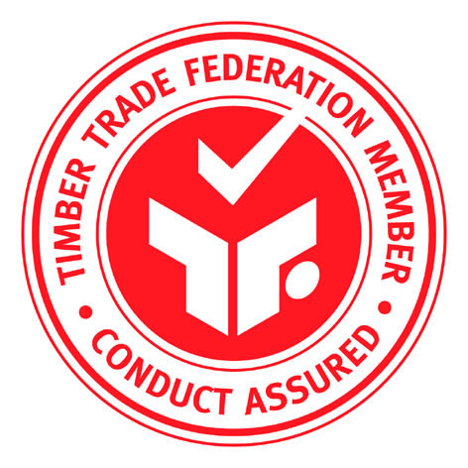
WHY HAS THE RPP BEEN DEVELOPED?

The RPP is a tool to assist members with the implementation of the Environmental Code of Practice in the TTF Code of Conduct which states that ‘Members are committed to sourcing their timber and timber products from legal and well-managed forests’.

The benefits of the RPP are that it provides:

- Reassurance to customers that a company is actively selecting those suppliers that can provide legal and progressively sustainable supplies.

- Opportunities to trade with environmentally committed buyers such as central government and major construction companies.

- Risk Management; by providing systematic information on suppliers and their environmental credentials and so help develop a preferential suppliers list.

WHAT DOES THE RPP HELP YOU TO DO?

The RPP helps members develop a purchasing policy that addresses environmental issues of concern to many consumers. This is a key issue for the timber industry of today. The RPP incorporates CITES and Sustainable Forest Management criteria in a supplier questionnaire and then assesses suppliers in terms of their ability to deliver against these criteria. The result is a ‘snapshot’ of each supplier’s environmental performance in the form of an estimate of the risk that the supplier may be offering illegal and unsustainable timber. The RPP also offers advice to suppliers on how they can improve their environmental performance and risk rating. The process is then independently audited to ensure that the RPP has credibility with customers and other stakeholders.

HOW DOES A COMPANY USE THE RPP?
Diagram: The RPP System
The RPP is a simple system with Word templates for ALL the
necessary documents. There are 3 key elements:
1. Developing RPP Company Commitments
The TTF Member writes an Environmental Policy for their company with the emphasis on continual improvement.

2. Risk Assessing Suppliers
The TTF Member sends a questionnaire to all their suppliers. The questionnaire contains five separate sections, four of these relate to general company information. The final section is the timber product data. The completed questionnaire and any supporting evidence are assessed against a set of standards (“Choice Tables”) that help member companies make an informed judgement, and grade their suppliers’ environmental performance as low, medium or high risk.

3. Compile Annual Management Report
The TTF Member compiles an Annual Management Report, summarising supplier assessments and setting improvement targets for the next 12 months which is audited by a TTF-
appointed independent auditor.

The RPP will be overseen by the TTF’s new Forests Forever Division which is made up of TTF members.

KEY POINTS

The System is Objective
- The RPP provides members with a systematic way of assessing and managing the risk that a supplier is offering illegal or unsustainable timber, thereby demonstrating compliance with the TTF’s Code of Conduct.
- Company targets demonstrate continuous improvement and are set by each TTF member independently but with minimum levels of improvement established by the TTF Forests Forever Division.

The System is Credible
- All commercial information is kept confidential (supplier details, individual risk ratings, etc.)
- The approach is supported by Government and NGO’s.
- The Management Report undergoes an external, independent audit.

The System Works
- The RPP Questionnaire and Choice Tables have undergone successful Pilot Testing to show that the procedure works within individual members companies.
- Full templates to manage the policy are provided by TTF (see www.ttf.co.uk/Members/Responsible).

